Ecumenical Lenten Resource 2012

Guidelines for Leaders and Participants

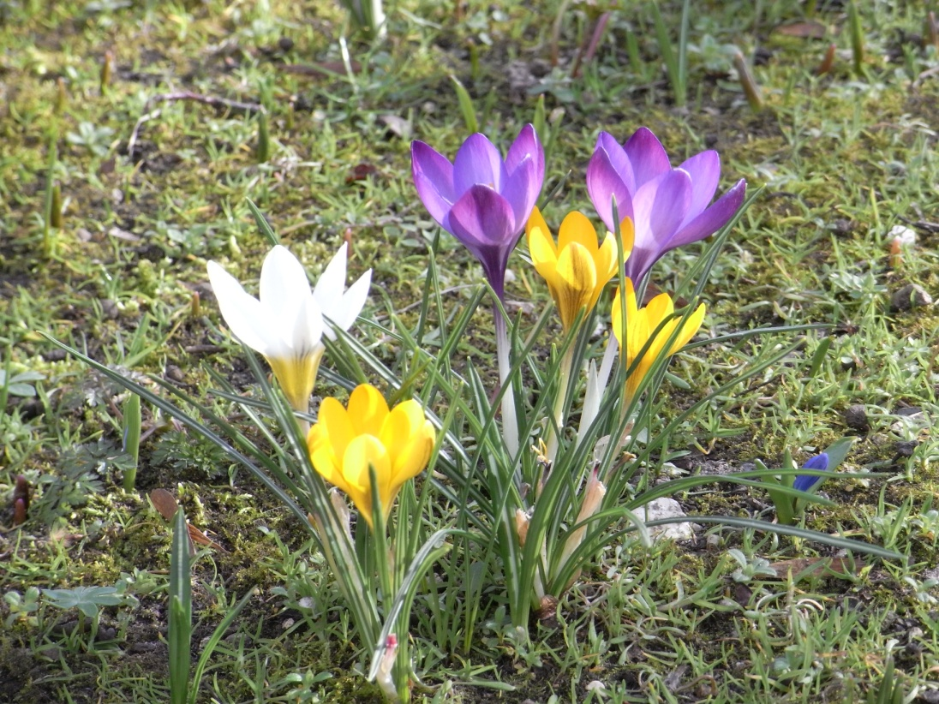
Fast, Pray, Give and Receive
Western Church
Ash Wednesday - 22 February 2012
Easter Sunday - 8 April 2012
Orthodox Church
The Great Lent starts on 20 February 2012
Easter Sunday -15 April 2012

Background and Hopes

Historically, Lent has been a time of preparation for the blessings of the Easter season. For forty years, an Ecumenical Resource has been commissioned every two years by Leaders of Christian Churches SA (formerly known as SA Heads of Christian Churches).
These resources have offered Christians, across South Australia and beyond, the opportunity to gather for personal reflection, to share the experience of Lent and to journey together towards Easter. People have been invited to consider their shared faith and what it means in practice: not only to engage in education and conversation but to move beyond the discussion process to inner conversion and to action.
Since the first ecumenical Lenten Study in 1972, thousands have come together in small groups and have come to know one another better. We give thanks for the sharing and growth in faith and action that has happened through these resources.
It is hoped that Christians from different backgrounds will continue to come together in 2012 around the resource Fast, Pray, Give and Receive and to reflect on how Lent can still be meaningful in the midst of today’s complexities and challenges.
Content

Fast, Pray, Give and Receive offers suggestions for four group sessions in Lent.
The first session focuses on the concept of Lent itself. The following three sessions are devoted to three spiritual disciplines which have been traditionally associated with Lent: fasting, prayer and almsgiving. Scriptural passages, wisdom from the past, contemporary insights and questions for reflection are offered where appropriate.
If only two group meetings in Lent are planned, the first and second sessions could be combined; similarly, the third and fourth.

Groups

Around 5-8 people probably works best.
Try to include people from different churches…contact neigbouring churches and invite the people to form clusters of groups with you and with others.
Are you willing to be a contact person for your area and to assist groups to be formed that are as ecumenical as possible?

Suggestions for Group Leaders
Venue
- Consider where you will gather. Meeting in the same place each time can assist with a sense of familiarity and leave people free to focus more comfortably on the resource.
- The person hosting the gathering need not be the person leading the conversation.
- Make sure that the space chosen for the discussion is comfortable and inviting so that people who are shy and hesitant feel welcome and able to contribute.
- If refreshments are offered during or after the meeting, ensure that they are kept simple.
Prayer
Consider who will take responsibility for arranging, setting up and leading prayer.

Arrange for any of the following to be available as needed:
- Bowl of water
- Hand towel
- Pebbles
- Candle
- Small table
- Remind everyone at Third Session to bring a small symbol of new life to the Fourth Session
- Some peaceful background music for the quiet sessions
- …
- …

Leading/facilitating the conversation
- At the start of the first session, take a few minutes to introduce one another.
- If not already done, the first session is an appropriate time to agree on how the group will be organised and led, the place and time it will meet for each session, and any other practical arrangements.
- We encourage the leader/facilitator to be familiar with the material before each session. Your knowledge will help keep the group focussed on the point of discussion or reflection.
- Share the reading and encourage all who are present to participate in the discussion. If possible, try to assist people who may find themselves dominating the session.
- Do not be afraid of silences. Some of the recommended readings and questions may trigger personal reflection that is not easily shared with others.
- Set time limits have not been given for each segment of the sessions, but it is usually wise to ensure that the group can finish within ninety minutes.

Reviewing the Resource and the Gatherings
Towards the end of your final gathering or soon after, you are encouraged to share your comments and insights about what worked well and what could be done differently in relation to:
- The resource
- The gatherings
Your responses will help shape future resources. Please gather them up and send to Ecumenical Lenten Resource 2012, c/- Geraldine Hawkes, SA Council of Churches – sacc1@picknowl.com.au or post to 65 Flinders Street, Adelaide SA 5000

